**United States Department of Agriculture**

Food and Nutrition Service

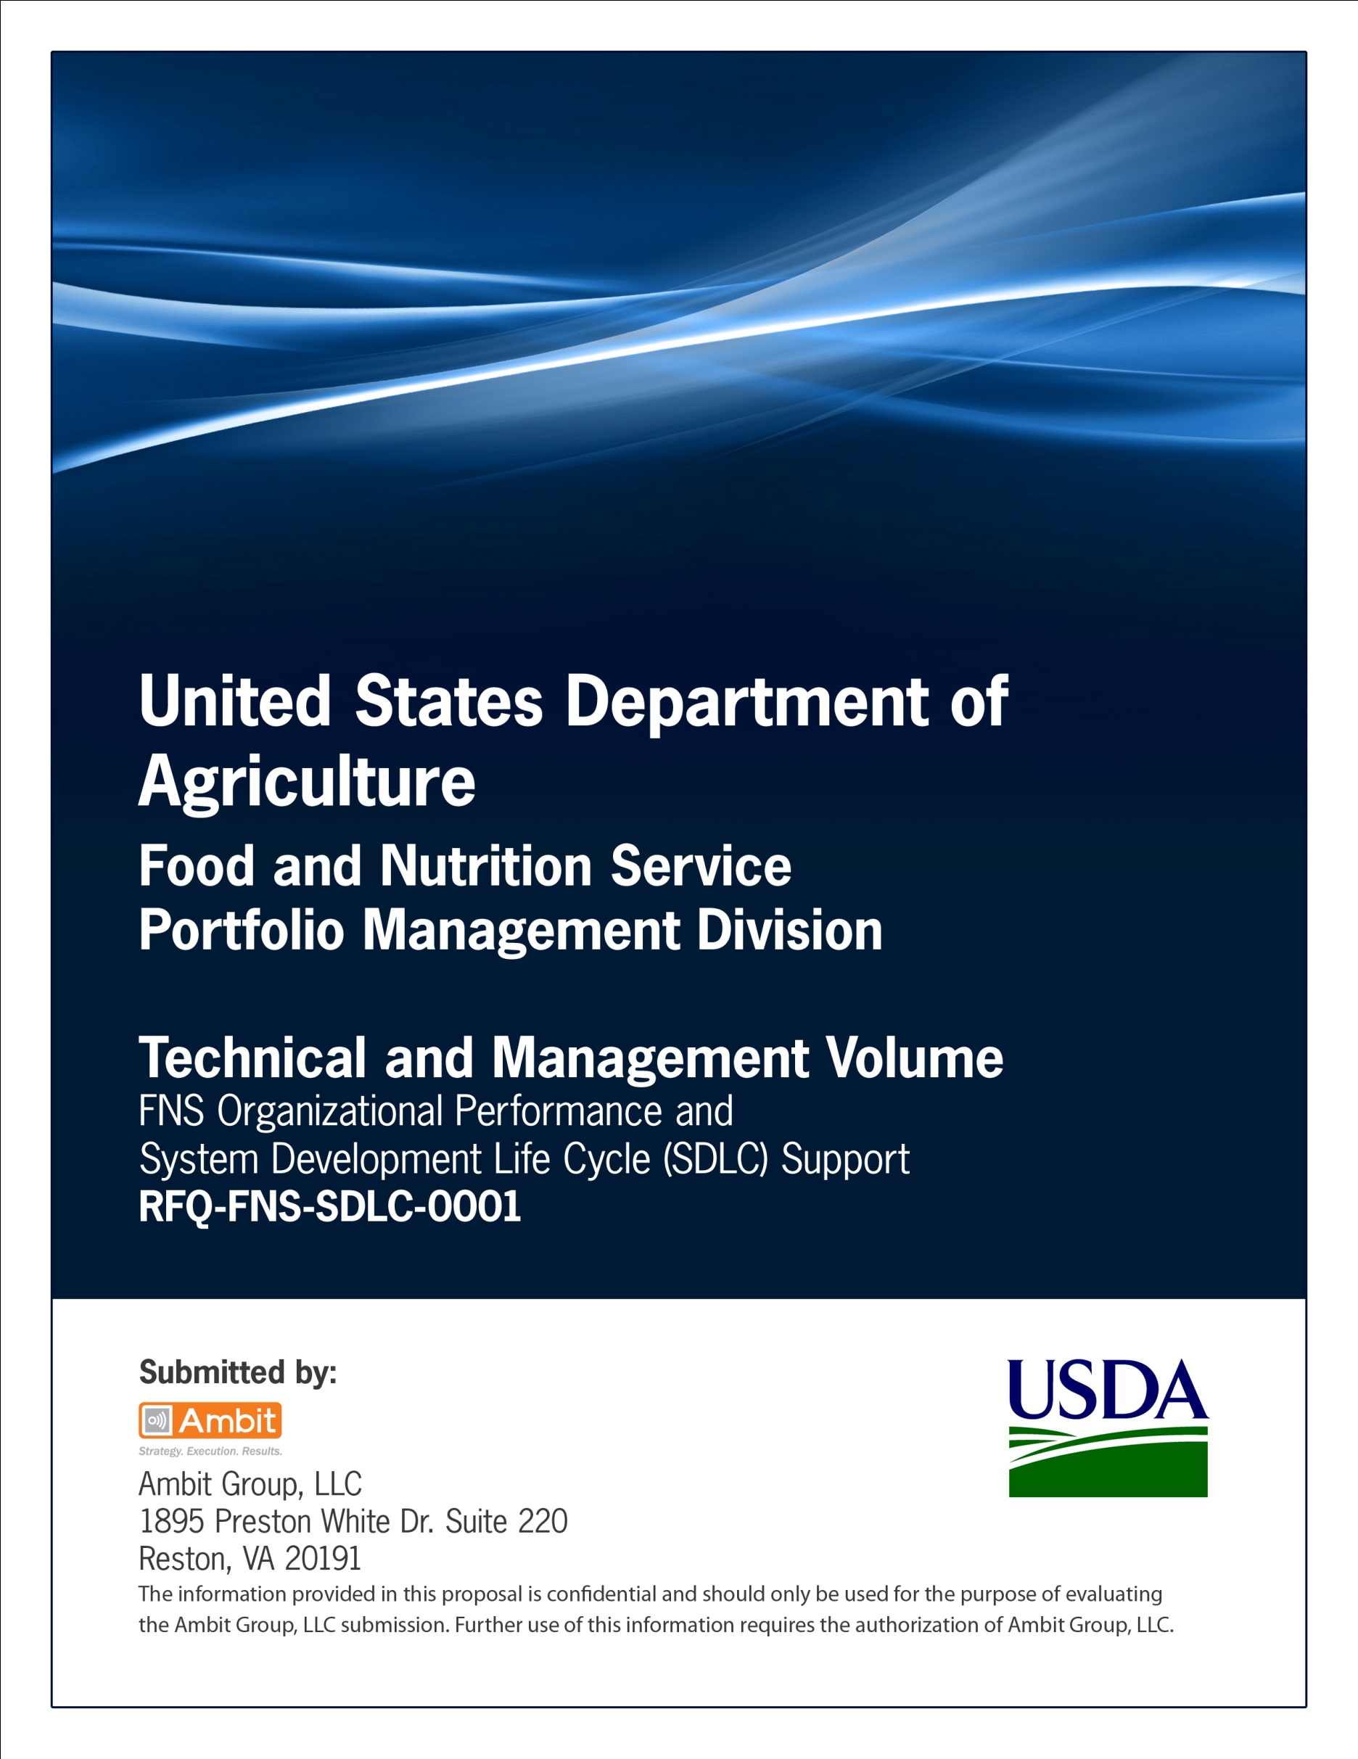

**FNS Office of Information Technology**

**Portfolio Management Division (PMD)**

**FNS Transition Plan Template**

**for**

**[Project or System Name]**

**Version 1.1**

September 09, 2013

**Revision History**

|  |  |  |  |
| --- | --- | --- | --- |
| **Version** | **Date** | **Author** | **Change Description** |
| 1.0 | 03-13-2013 | IT Governance Branch (ITGB) | Created the document. |
| 1.1 | 09-09-2013 | IT Governance Branch (ITGB) | Re-formatted the document. |
| 1.2 |  |  |  |
| 1.3 |  |  |  |

**Contact Information**

|  |  |
| --- | --- |
| **Area of Concern** | **Contact Person** |
| IT Governance Lead | Kevin Russ |
| SDLC Coordinator | Syed Jaffery |
| ITIRB Coordinator | Sunny Dilawari |
| Portfolio Management Division Director, Chief Portfolio Officer | Jacqueline Butler |
| Program Management Branch Chief | Allison Willcox |

Contents

Glossary 4

1. Introduction 6

1.1. Purpose of Transition Plan 6

1.2. System Overview 6

1.3. Scope 6

1.4. “As Is” Functionalities 6

1.5. Documentation to be Transitioned 6

1.6. Interfaces 6

2. Project Organization and Resources 6

2.1. Organizational Structure 6

2.2. RACI Chart 6

2.3. Points of Contact 8

3. Strategies 8

3.1. Strategies 8

3.2. Tools 9

3.3. Options 9

3.4. Select Strategy 9

4. Transition Schedule, Tasks and Activities 9

4.1. Time Schedule 9

4.2. Installation 10

4.3. Operations and Support 10

4.4. Conversion 10

4.5. Maintenance 10

5. Resource Requirements 10

5.1. Software Resources 10

5.2. Hardware Resources 11

5.3. Facilities 12

5.4. Personnel 12

5.5. Other Resources 12

6. Acceptance Criteria 12

7. Reporting Procedures 12

8. Risks and Contingencies 12

8.1. Risks 12

8.2. Contingencies 12

9. Transition Impact Statement 12

10. Configuration Control 13

Appendix A: References 14

Approvals/Signatures 15

# Glossary

| **Acronym** | **Description** |
| --- | --- |
|  |  |
|  |  |
|  |  |
|  |  |
|  |  |
|  |  |
|  |  |
|  |  |

# Introduction

## Purpose of Transition Plan

The purpose of transition planning is to layout the tasks and activities that need to take place to efficiently move a product from the development or pilot environment to the production, operations and maintenance environment.

## System Overview

This section provides a brief description of the information system and the high level functionality provided by the system.

## Scope

Provide a description of the intended scope of the system, how it will accomplish its purpose.

## “As Is” Functionalities

Provide the major performance requirements and current functionalities of the “As-Is” system.

## Documentation to be Transitioned

Include a listing of all the documentation related to the system that is to be transitioned to the operations area includes any security or privacy protection consideration associated with its use.

## Interfaces

Describe whether this system relates to or depends on any existing system.

|  |  |
| --- | --- |
| System Name | Relationship |
| For example: |  |
| System XYZ | Web service provider |

# Project Organization and Resources

## Organizational Structure

Describe the organizational structure of the project team, including management and other review authorities.

## RACI Chart

This section displays the RACI Chart for the project.

| **Phases** | **Templates** | **Roles** | | | | | | | | |
| --- | --- | --- | --- | --- | --- | --- | --- | --- | --- | --- |
|  | R-Responsible  A-Accountable  C-Consult  I-Informed | **Project Sponsors** | **SME’s** | **OIT PM** | **Business Analyst** | **IT Architect** | **Network Managers** | **Developers** | **Testers** | **End Users** |
| Initiation | **Business Case** | R | CI | A | I | I | I | I | I | I |
| **Project Plan** | A | C | R | I | I | I | I | I | I |
| Requirements Gathering & Analysis | **PTA, PIA, SORN, Electronic Information System Questionnaire for Records Management Scheduling** | C | C | R/A | I | I | I | I | I | I |
| **System Requirements Specification** | C | C | A | R | I | I | I | I | I |
| Design | **Procurement Documents** | A | C | R | I | I | I | I | I | I |
| **System Design Document** | I | I | A | C | R | C | C | I | C |
| Development | **Test Plan** | I | I | A | C | C | I | I | R | I |
| Integration | **Transition Plan** | I | I | A | C | R | I | C | I | I |
| Testing | **Test Results** | I | I | A | C | C | I | C | R | I |
| Implementation | **Installation Document** | I | I | A | C | R | C | R | I | I |
| **Application Guide** | R | R | A | R | C | C | C | I | I |
| Operations/  Maintenance | **Standard Operating Procedures** | I | I | A | I | I | R | R | R | I |
| Disposition | **System Disposition Plan** | R | I | R/A | I | I | I | I | I | C |
| **Post Termination Review Report** | C | I | R/A | I | I | I | I | I | C |

## Points of Contact

List the names, titles, and roles of the major participants in the project.

| **Name** | **Title** | **Contact Phone Number** | **Contact Email** |
| --- | --- | --- | --- |
|  | Project Sponsor |  |  |
|  | OIT Project Manager |  |  |
|  | SME |  |  |
|  | Business Analyst |  |  |
|  | Architect |  |  |
|  | Developer |  |  |
|  | Tester |  |  |
|  | End User |  |  |

# Strategies

## Strategies

Identify the strategies to be used in the transition process.

## Tools

Specify tools to be used as part of the Transition Plan.

## Options

Identify all the options for moving the product from its present state into production/operations.

Provide following information for each option:

|  |  |  |  |  |  |
| --- | --- | --- | --- | --- | --- |
| **Option Description** | **Advantages** | **Disadvantages** | **Risks** | **Estimated Time Frames** | **Estimated Resources** |
| Describe the option. | List the advantages of using the option. | List the disadvantages of using the option. | List risks involved with the option. | Specify time frames for moving product from present state into production/operations. | Specify resources required for the option. |

## Select Strategy

Evaluate each of the transition options, comparing them to the transition requirements, and selecting the one that is most appropriate for the project.

# Transition Schedule, Tasks and Activities

Develop detail schedules for the selected transition strategy.

## Time Schedule

The time schedule shall include the following information:

**Equipment installation**

Include in this section an installation schedule for equipment (new or existing), software, databases, etc.

**Training**

Include provisions for training personnel with the operational software and target computer(s), as well as any maintenance software and / or host system(s).

**Conversion**

Describe the developer’s plans for transitioning the deliverable product to the maintenance organization.

For example:

* Planning/coordination of meetings,
* Preparation of items to be delivered to the maintenance organization,
* Packaging, shipment, installation, and checkout of the product maintenance environment,
* Packaging, shipment, installation, and checkout of the operational software, and
* Training of maintenance/operational personnel.

**Deployment**

Describe deployment activities in this section.

## Installation

Installation consists of the transportation and installation of the product from the development environment to the target environment(s). It includes any modifications to the product, checkout in the target environment(s), and customer acceptance.

**Process**

Describe installation process.

**Work Around**

In case any problems arise during installation process, define temporary work-around(s).

## Operations and Support

Define user operation of the product and ongoing support procedure.

Support includes providing technical assistance, consulting with the user, and recording user support requests by maintaining a Support Request Log.

## Conversion

Address any data or database transfers to the product and its underlying components.

## Maintenance

Maintenance activities are concerned with the identification of enhancements and the resolution of product errors, faults and failures.

# Resource Requirements

Include estimates for resources (hardware, software, and facility) as well as any special resources (i.e. service and maintenance contracts), and staffing for the selected transition strategy.

## Software Resources

Describe any software and associated documentation needed to maintain the deliverable product.

Include the following information:

|  |  |  |  |  |  |  |
| --- | --- | --- | --- | --- | --- | --- |
| **Software**  **Name** | **Software**  **Release/Version Number** | **Software**  **Configuration** | **Software**  **User Manual** | **Source of Software** | **Vendor Support** | **Software**  **Licensing** |
| Specify software name. | Specify release and/or version number of the software. | Include configuration details of the software. | Include references to user/operator manuals or instructions. | Specify source of the software whether it is acquirer-furnished, currently owned by the organization, or to be purchased. | Include information about vendor support, whether the item is currently supported by the vendor or it is expected to be supported at the time of delivery. | Specify details about licensing, usage and ownership rights. |

## Hardware Resources

Describe the hardware and associated documentation needed to maintain the deliverable product.

|  |  |  |  |  |  |  |
| --- | --- | --- | --- | --- | --- | --- |
| **Hardware**  **Name** | **Model/**  **Version** | **Hardware User manual** | **Source of Hardware** | **Manufacturer Support** | **Hardware Licensing** | **Ownership Rights** |
| Specify name of the hardware. | Specify model number/version of the hardware. | Include references to user/ operator manuals or instructions. | Specify source of the hardware whether it is acquirer-furnished, currently owned by the organization, or to be purchased. | Include information about manufacturer support. | Include licensing and usage information. | Include information about ownership rights whether the items are currently supported by the manufacturer, or will be in the future, and whether licenses will be assigned to the maintenance organization and the terms of such licenses. |

## Facilities

Describe the facilities to be used. Highlight the location of project-specific resources such as software engineering environment and software test environments. Supply schedule when facilities will be needed.

For example: Special buildings, rooms, mock-ups, building features such as raised flooring or cabling, building features to support security and privacy protection requirements, building features to support safety requirements, special power requirements, etc.

## Personnel

List the personnel needed to maintain the deliverable product.

|  |  |  |  |  |
| --- | --- | --- | --- | --- |
| **Number** | | **Types of Support** | **Skill Levels** | |
| Include number of personnel. | Include job descriptions. | | | Include description of skill levels. |

## Other Resources

Identify any other consumables (i.e. technology, supplies, and materials) required to support the product.

# Acceptance Criteria

Establish the exit or acceptance criteria for transiting the product.

# Reporting Procedures

Define the reporting procedures for the transition period.

# Risks and Contingencies

Identify the risks and contingencies faced by the transition process with special attention given to minimizing operational risks.

## Risks

1. Risk #1
2. Risk #2
3. Risk#3

## Contingencies

1. Contingency #1
2. Contingency #2
3. Contingency #3

# Transition Impact Statement

Describe how the system’s implementation is expected to impact the network infrastructure, support staff and user community.

# Configuration Control

The Transition Plan information should be subject to the configuration control process for the project. Subsequent changes are tracked to ensure that the configuration of the transition plan information is known at all time.

# Appendix A: References

Insert the name, version number, description, and physical location of any documents referenced in this document. Add rows to the table as necessary.

The following table summarizes the documents referenced in this document.

|  |  |  |
| --- | --- | --- |
| **Document Name** | **Description** | **Location** |
| Document Name and Version Number | Document description | URL or Network path where document is located |
|  |  |  |
|  |  |  |

# Approvals/Signatures

The undersigned acknowledge that they have reviewed the [name of document] document and agree with the information presented within this document. Changes to this document will be coordinated with, and approved by, the undersigned, or their designated representatives.

|  |  |  |  |
| --- | --- | --- | --- |
| Signature: |  | Date: |  |
| Print Name: |  |  |  |
| Title: |  |  |  |
| Role: | [Project or System Name] Project Manager |  |  |
|  |  |  |  |
| Signature: |  | Date: |  |
| Print Name: |  |  |  |
| Title: |  |  |  |
| Role: | [Project or System Name] Business Owner |  |  |
|  |  |  |  |
| Signature: |  | Date: |  |
| Print Name: |  |  |  |
| Title: |  |  |  |
| Role: | Organization’s Approving Authority |  |  |